**User Models**

**and UI Prototype**

Group members:

KrishnaSai Reddy Patil

Pranav Jaipurkar

Aman Geetey

Tigist Shibeshi

Yili Zhang

Vijayadhaarani Vijayaarunachalam

**Techno-Tidbits**

Contents

**1. Persona Description :** **2**

1.1 Working Professional 2

1.2 Student 3

1.3 Hearing Impaired 4

1.4 Malicious User 4

1.5 Instructor 5

1.6 Requirements Identified from the Modelling 6

**2. User Interface Flow Model** **6**

2.1 User Interface Flow Diagram 6

**3. Storyboards** **7**

3.1 Joyce’s Storyboard 7

3.2 Ram’s Storyboard 8

3.3 Ryan’s Storyboard 9

3.4 Bob’s Storyboard 10

3.5 George’s Storyboard 11

# 

# 

# **1. Persona Description :**

## 1.1 Working Professional

**Name** : Joyce

* Joyce is a working professional, who is 40 years old.
* He works at Accenture and has worked in several projects.
* He never hesitates to learn something new.
* He is living with his wife and has two children. His wife is a homemaker and both his children are studying

**Goals**

* To grow a strong industry reputation
* To upgrade his skills for the next interview
* To study at his own phase
* Likes to practice what he learns.

**Scenario:**

* Since he is the only person going to work in his family, he couldn’t afford to pay for courses
* His current project is nearing its due date and he must face interviews for taking up the next project.
* He spends quality time with his family and doesn’t want to miss having dinner with his family.

## 

## 

## 

## 1.2 Student

**Name** : Ram

* Ram is an undergrad student, Junior – Computer Engineering
* He lives near campus with his three roommates
* His biggest fear is not getting a good job after graduation
* He always looks up to his professor or friends to know things
* He prefers watching videos and examples instead of reading a lengthy paragraph.

**Goals**

* To maintain good grades
* To make his family proud by getting a good job
* To be able to seek help while learning new stuff
* To maintain a social life

**Scenario**

* Ram spends two hours per day studying after finishing his homework
* He is given multiple suggestions for what skills he must improve in order to land in a good job.
* He is reluctant to spend money on courses as he is not sure about what he wants to learn.

## 

## 

## 

## 

## 1.3 Hearing Impaired

**Name** : Ryan

* Ryan is a Freelancer,who is 50 years old
* He lost his hearing in a recent accident
* He lives with his wife and daughter, his daughter is pursuing a bachelor’s in computer science. He is the sole breadwinner of his family.
* He his passionate about coding
* He wants to upskill by learning new technology so that he can earn more money, keep himself engaged with what he loves and can even assist his daughter in learning new skills.
* He Prefers Subtitles as he doesn’t know sign language or use any Hearing aids.

**Goals**

* Learn and explore new technology
* Identify the system which would provide subtitles for a video course
* To take up new challenges and Earn more money
* To assist his daughter in learning new technology

**Scenario**

Ryan is working on an old skill which wouldn’t let him make more money, so he wants to upskill by learning niche skills. Keeping in consideration about his financial status and hearing impairment, he is looking for systems selectively which would offer courses for a minimal cost or for free with video tutorials having subtitles and chat-box or discussion forums to clear doubts.

## 

## 1.4 Malicious User

**Name** : Bob

* He always stays anonymous and presents himself as bob
* He is a Hacker
* He is greedy for money
* He is an expert in breaking into computer systems in order to steal, change or destroy information
* He always finds ways to make easy money

**Goals**

* To break into system and modify/delete course content
* To modify/delete grades of completed assignment/quiz
* Doing quiz/assignment on behalf of someone
* To post answers of quiz/assignments on online forums
* Stealing data from the system
* To earn money easily and lead a lavish life

**Scenario**

* Bob being greedy for money, indulges in unethical practices by breaking into the system to steal data and post quiz/assignment answers on public forums or on his website
* He makes a deal with Competitor of system and Modify/delete course content or steal and provide user information to the competitor
* He blackmails the system owner for money in order to not reveal data

## 

## 

## 

## 

## 1.5 Instructor

**Name** George Mathis

- George is a computer scientist working at Oracle Corporation,

- He is 45 years old

- He delights in serving his community

- He joined TechnoTidBits Inc. to teach computer programming language pro bono

- TechnoTidBits Inc is an e-learning website that offers courses free of charge

- He lives with his wife and three children.

- He spends quality time with his family and travels with them for vacation.

**Goals**

- To be successful/outstanding computer scientist, Philanthropist

- To be a dedicated father and husband

- To be a dedicated public servant for greater good

- To enjoy his life with his family

**Scenarios**

* Since it is his goal to serve his community, he would like to be a part of organizations that serves community free of charge
* It is his desire to teach programming language since he is an accomplished software developer
* Outside working hours, he spends time with his family

## 

## 1.6 Requirements Identified from the Modelling

1. Discussion Board

2. Subtitles for the video lectures

# 2. User Interface Flow Model

## 2.1 User Interface Flow Diagram

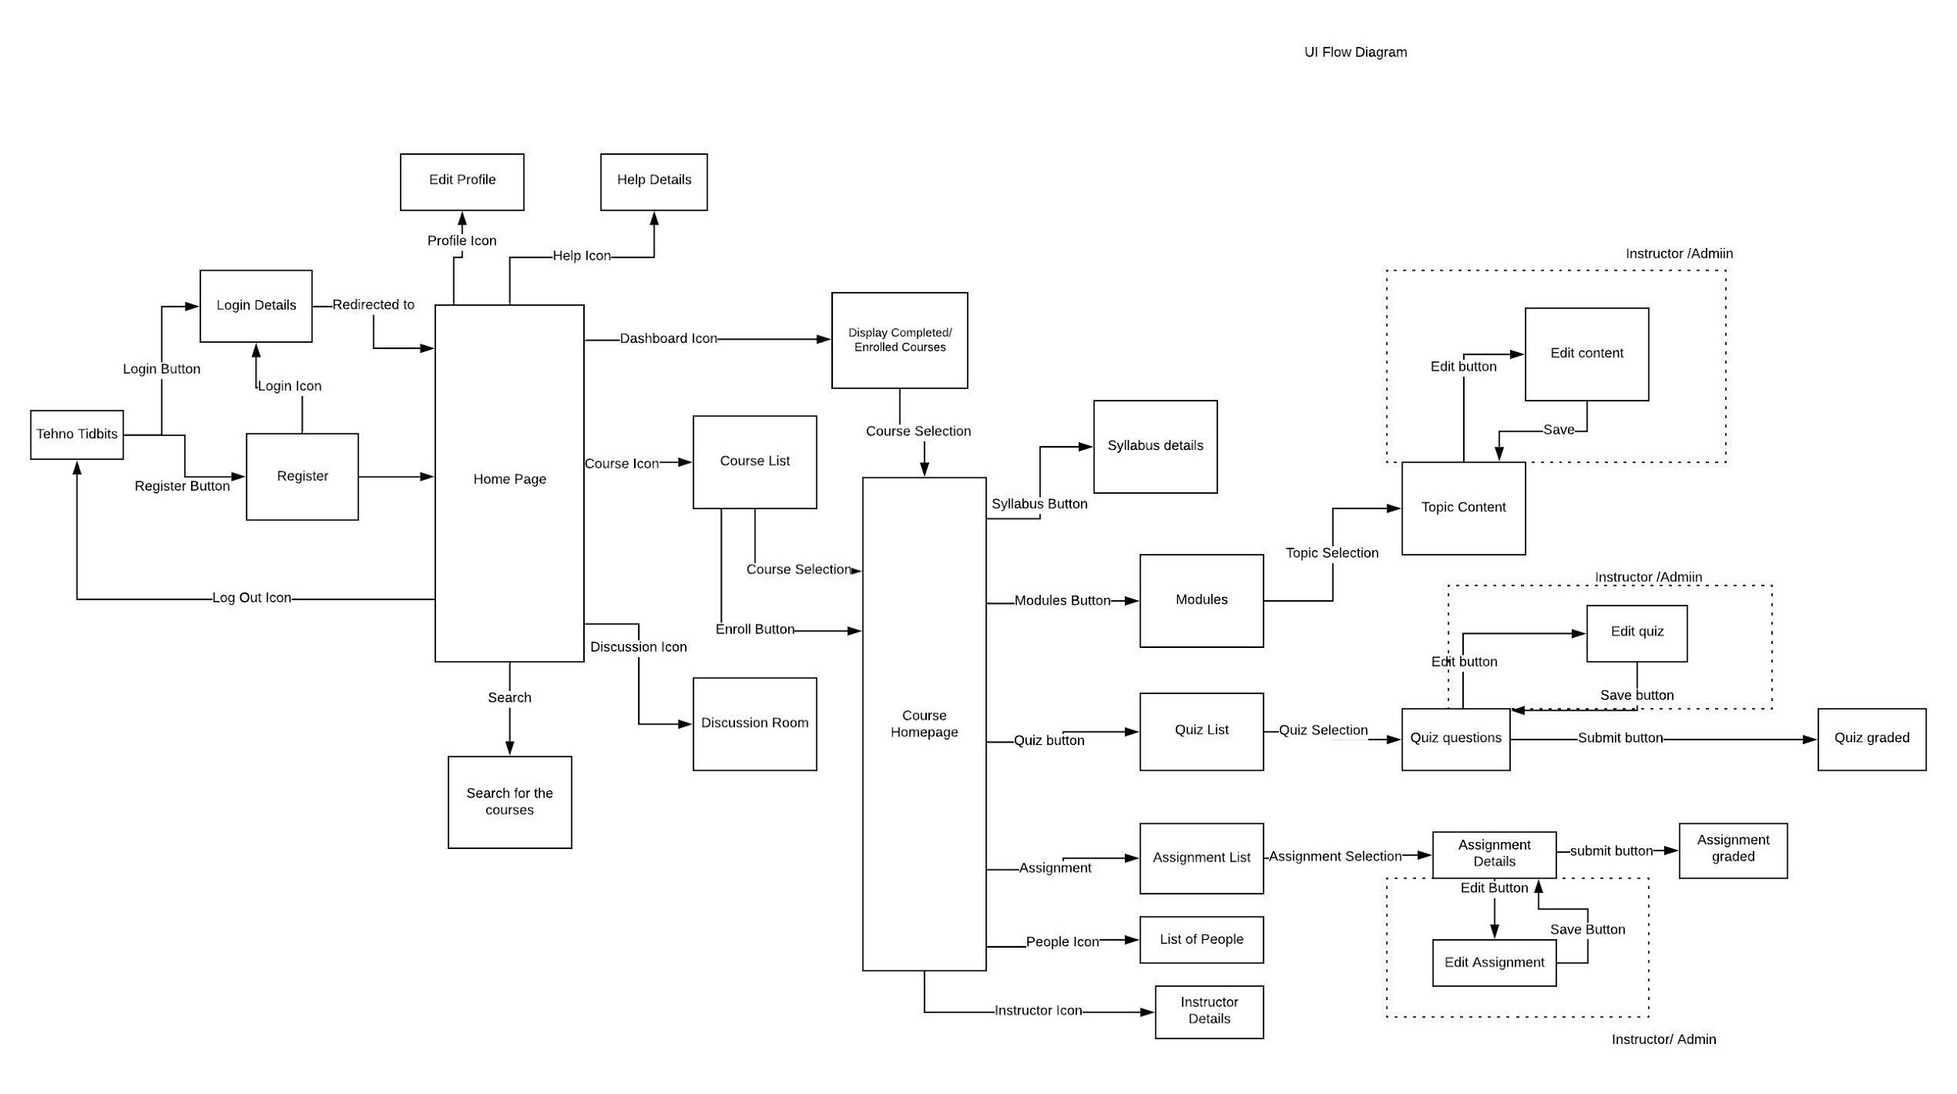

# 3. Storyboards

## 3.1 Joyce’s Storyboard

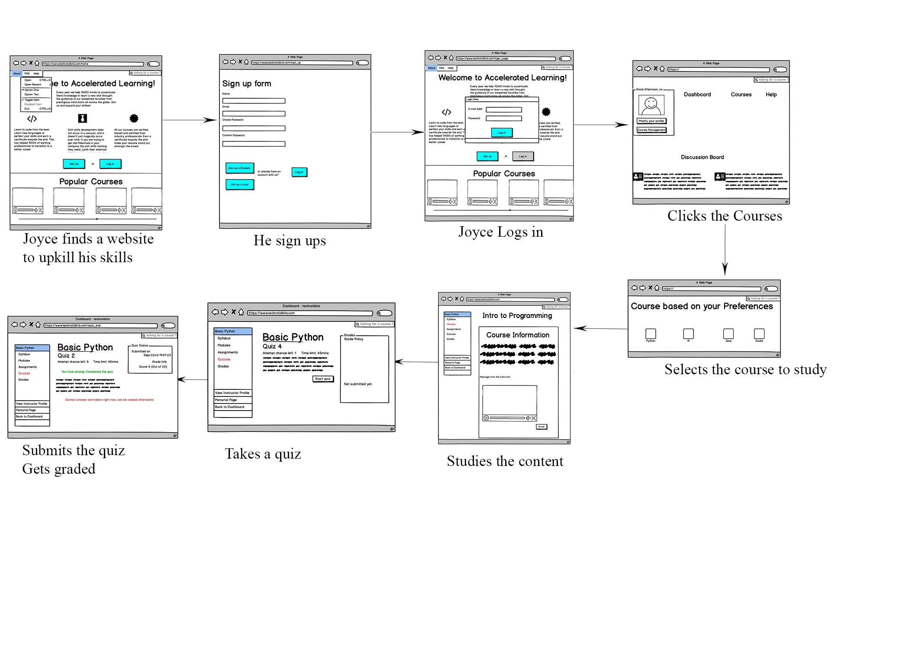

## 3.2 Ram’s Storyboard

## 

## 

## 

## 

## 

## 

## 

## 3.3 Ryan’s Storyboard

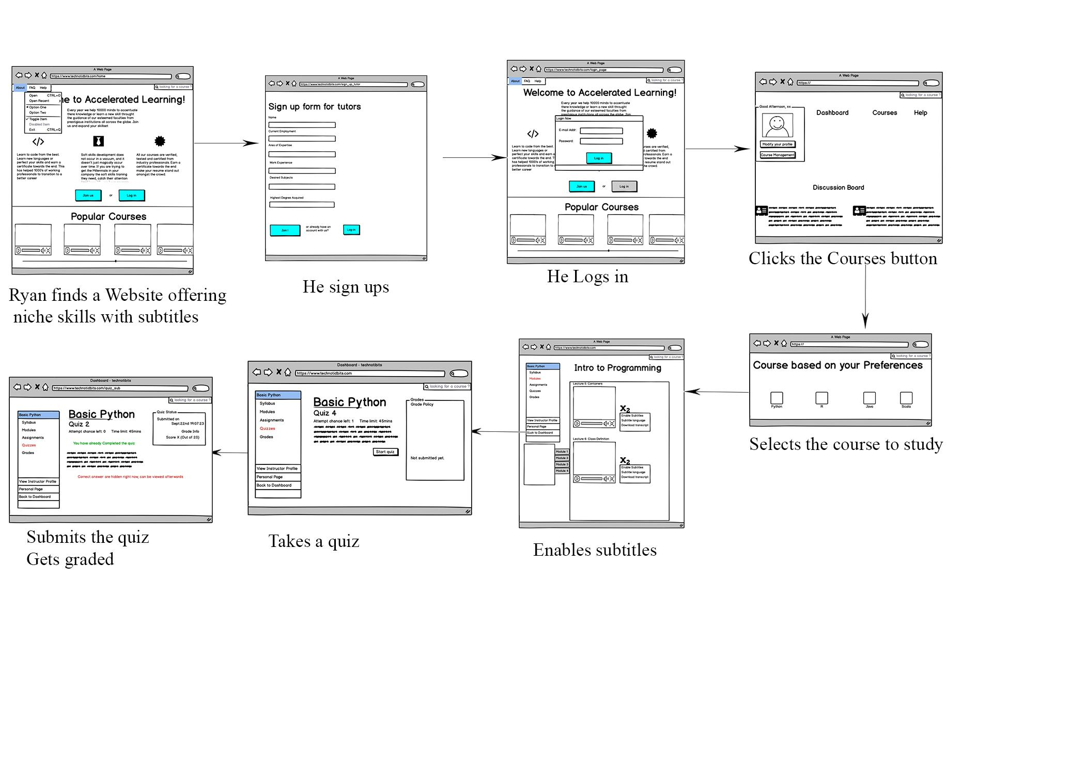

## 3.4 Bob’s Storyboard

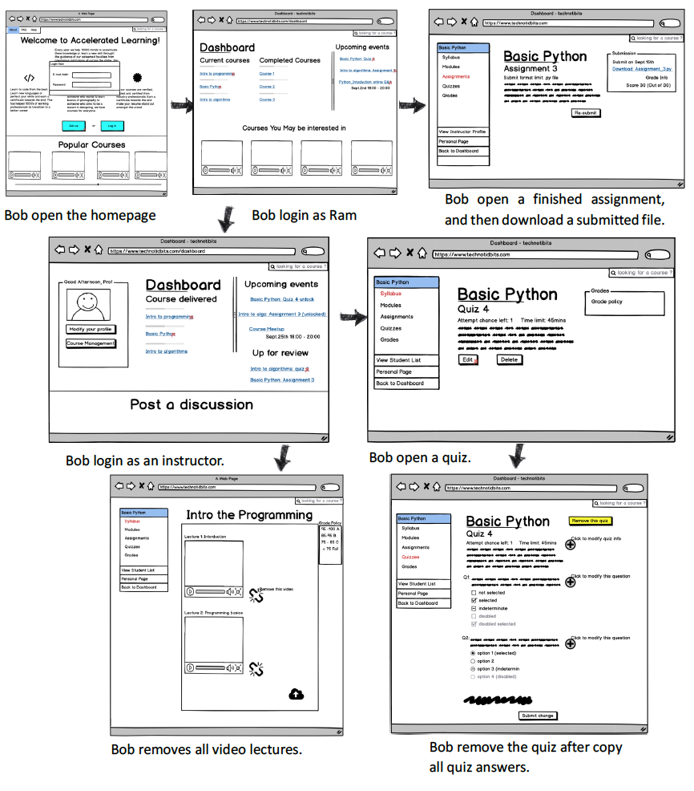

## 3.5 George’s Storyboard

